**Steps:**

1) Download Eclipse IDE for Enterprise Java Developers and Install.

Open Eclipse and Choose your workspace and click on it.



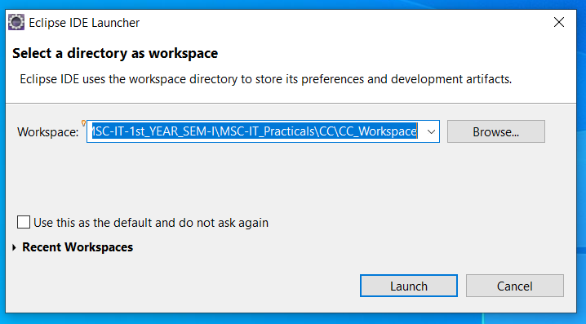

2)Click on >> **Help** >> **Eclipse Marketplace**

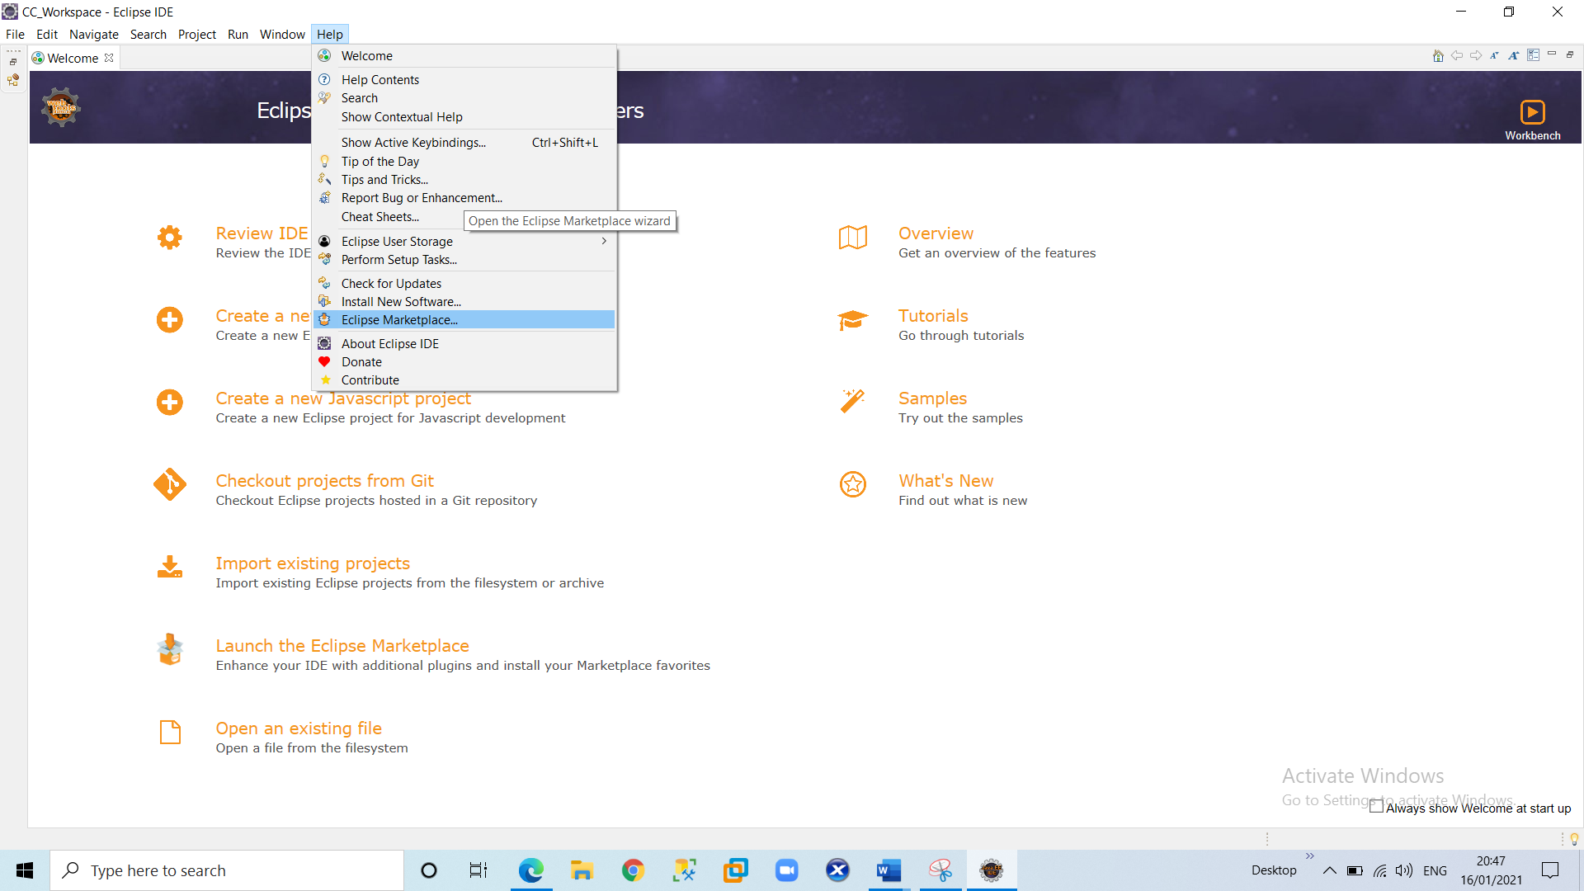

3) In **Find** Search Box**: Search for “Google cloud tools for eclipse”** and click on **Install** button. After complete installation of the plugin restart the Eclipse.

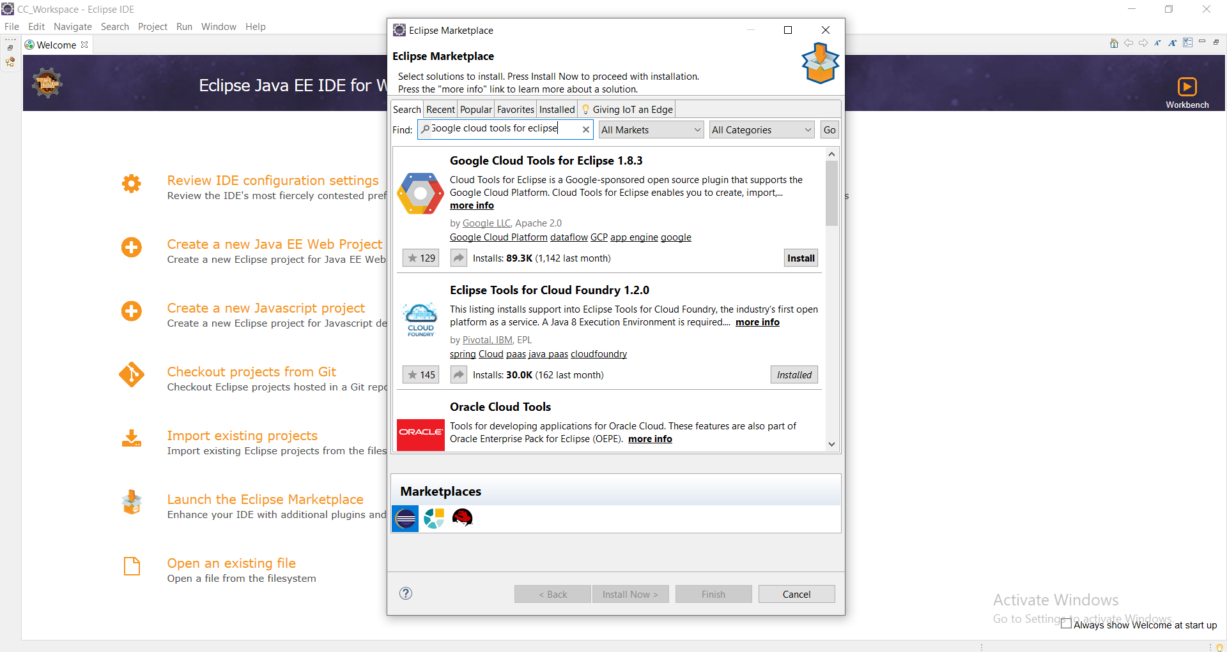

4) Click on ‘**File**’ menu and select >> **New** >> **Other** and search with “Google” keyword and select Google **App Engine Standard Java Project** under **Google Cloud Platform** and click on Next.

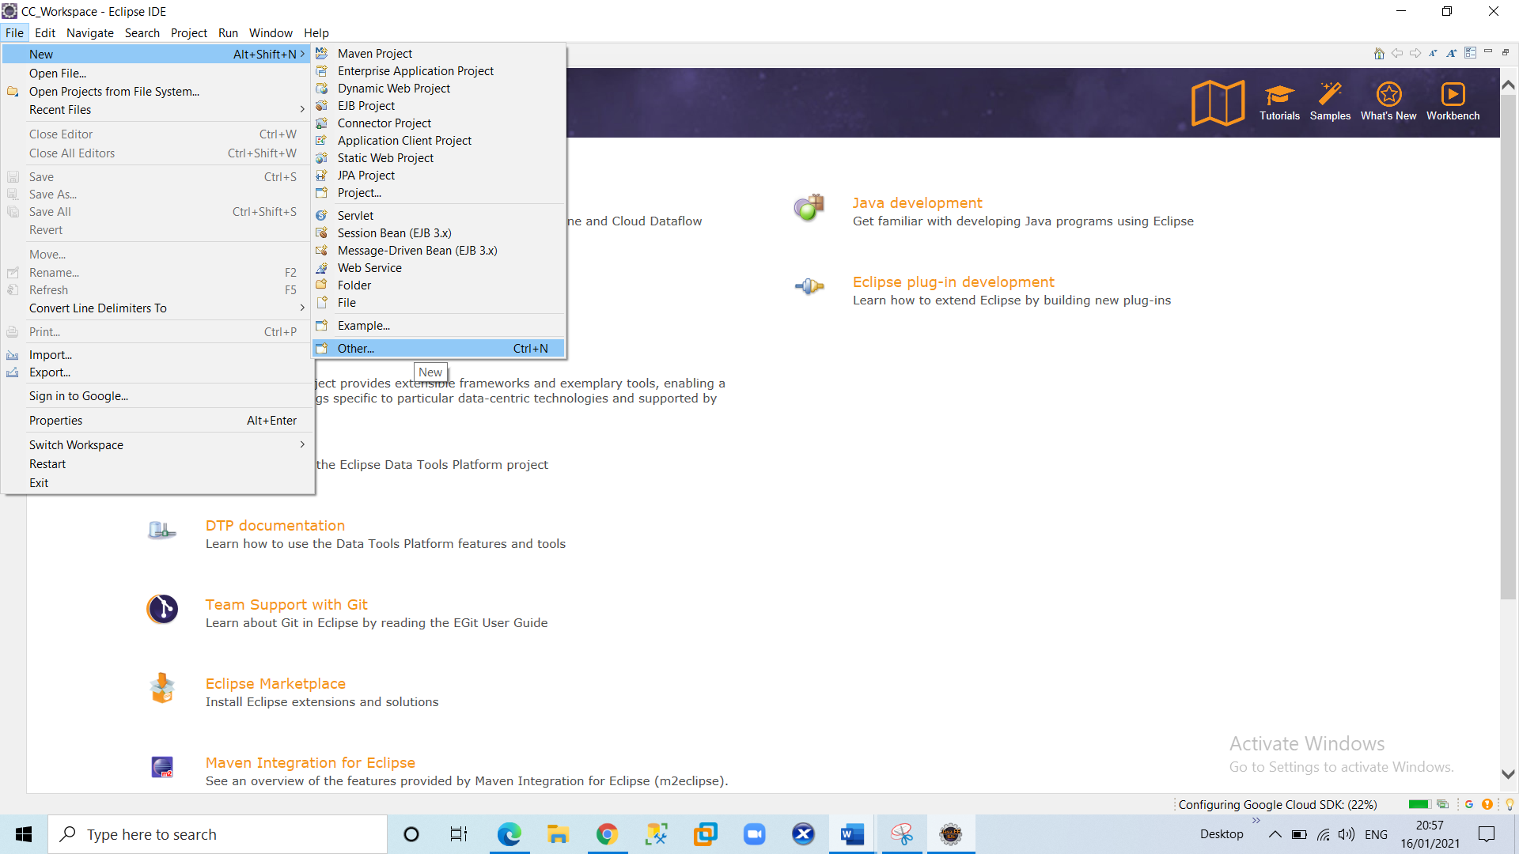

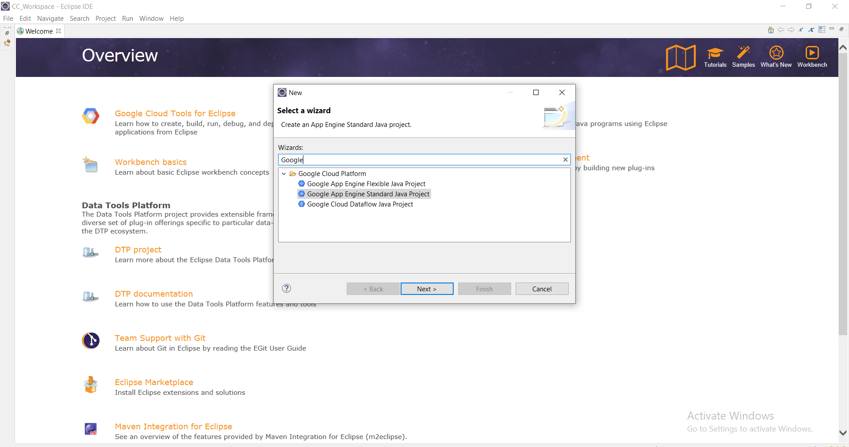

5) Enter **Project Name** “**FirstGAEProject”** and Package Name “**com.GAE”** and then Click on >> **Next** >> **Finish.**

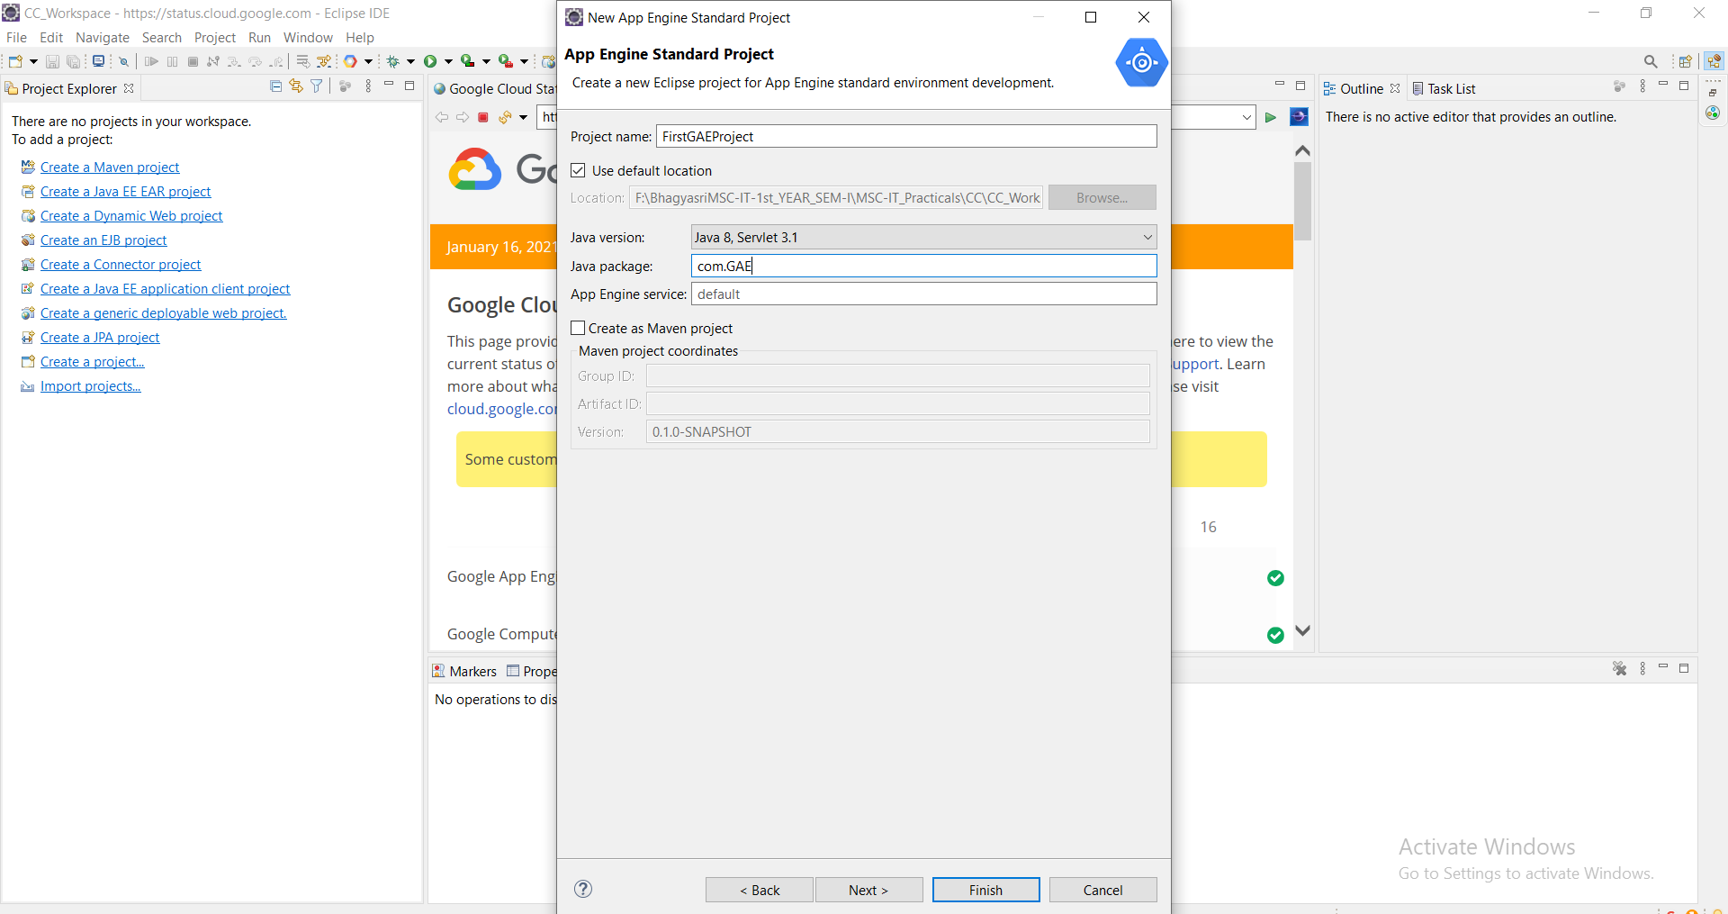

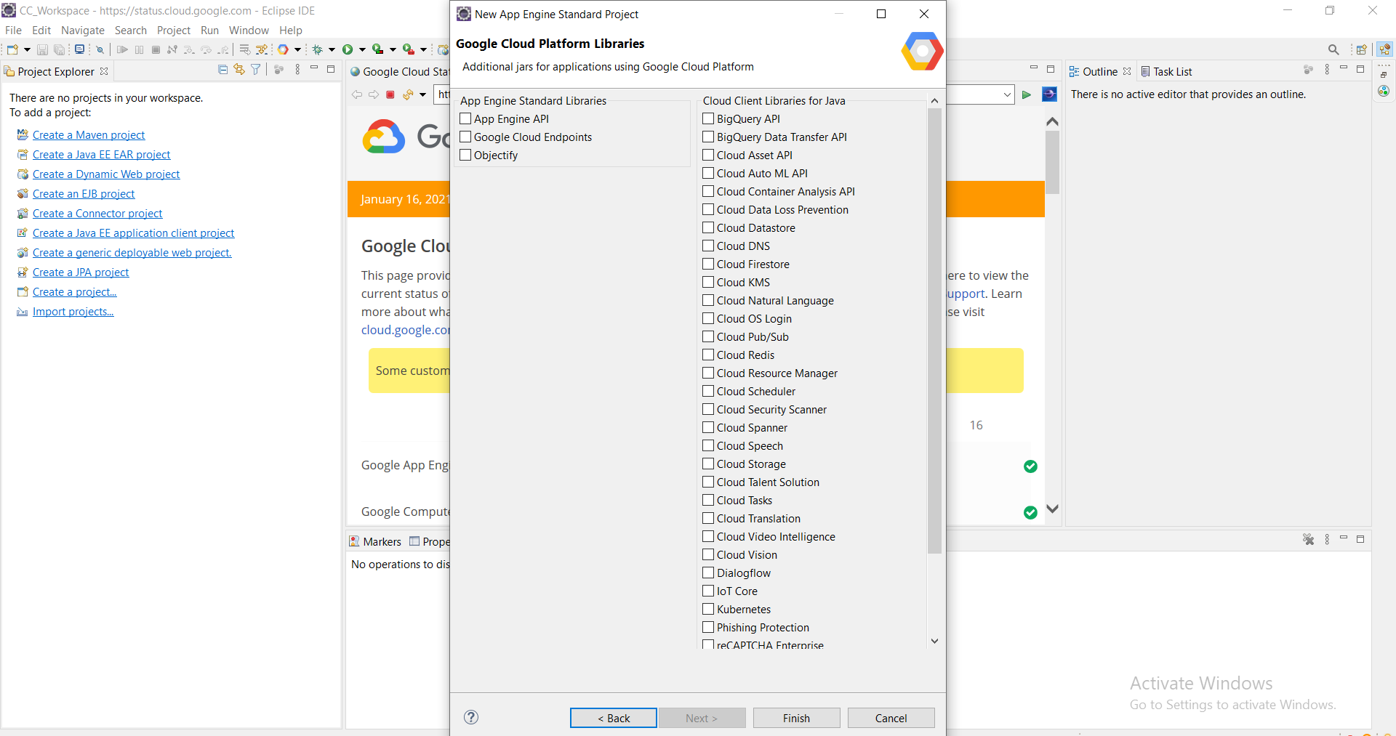

6) Open project hierarchy.

Edit the file as required (Unedited file too can be used. Here the editing is done to “what should be displayed” on the browser). Save the file.

**HelloAppEngine.java**

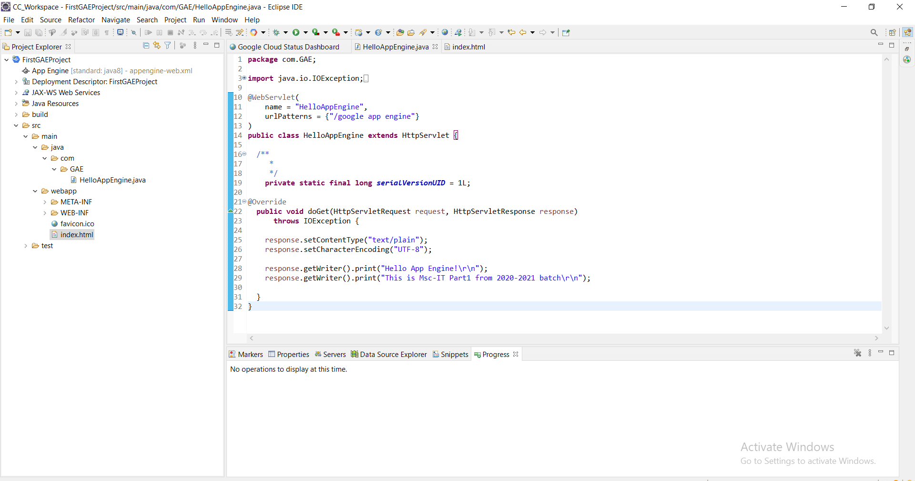

**index.html**

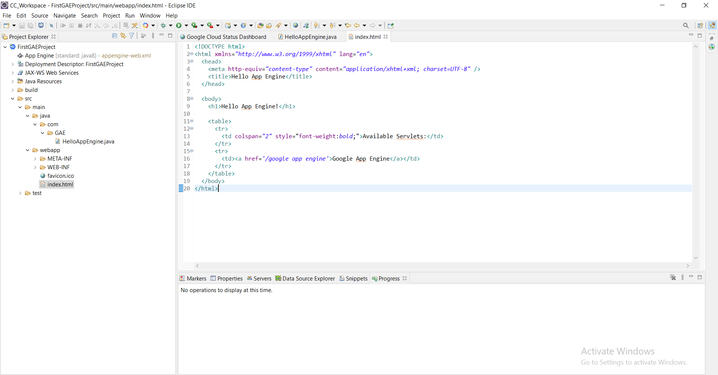

7)Configuring “App Engine Standard” Server. Click on the link to create a new server under **Server tab.**

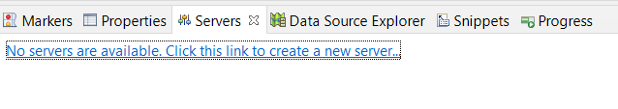

Click Next.

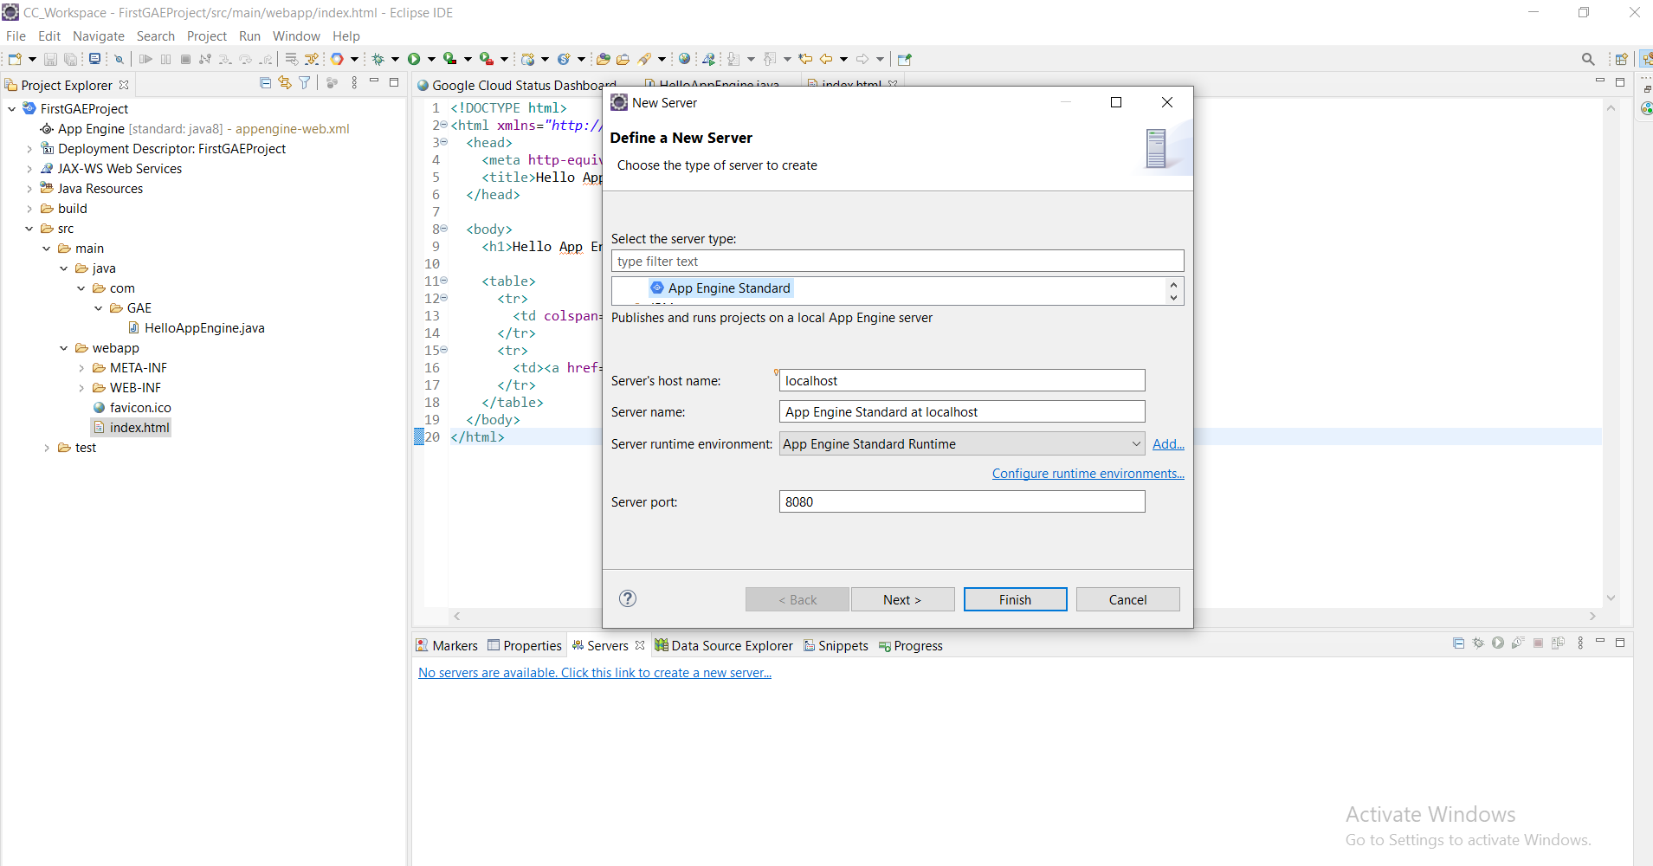

Add the “FirstGAEProject” and click on “Finish”.

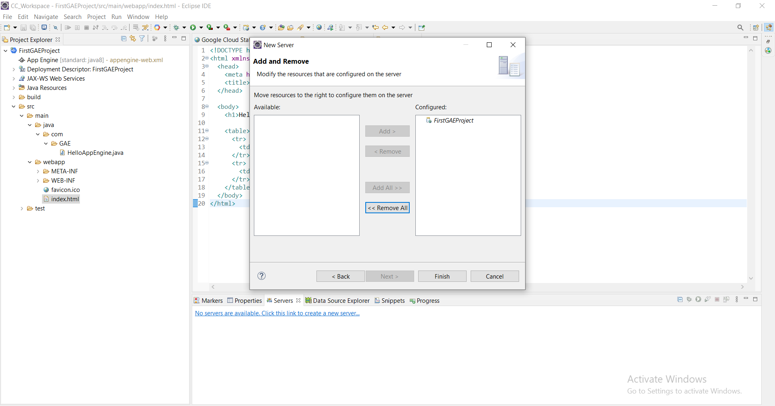

8)Start the “App Engine Standard” server.

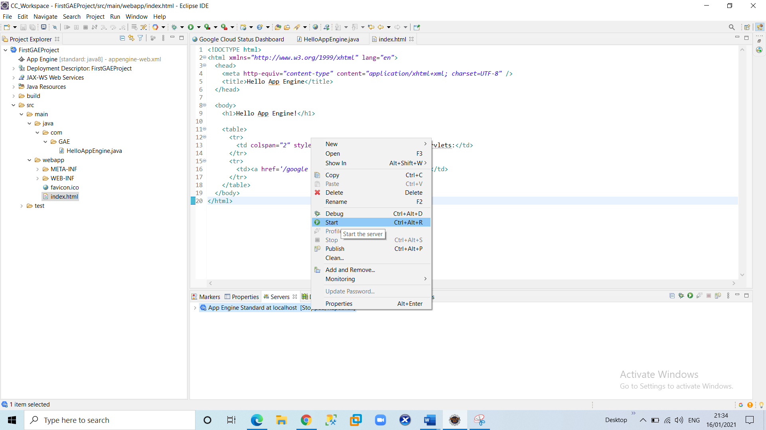

9) In the browser (Here, Google Chrome) type the address as “localhost:8080” which is "Default" for http protocol

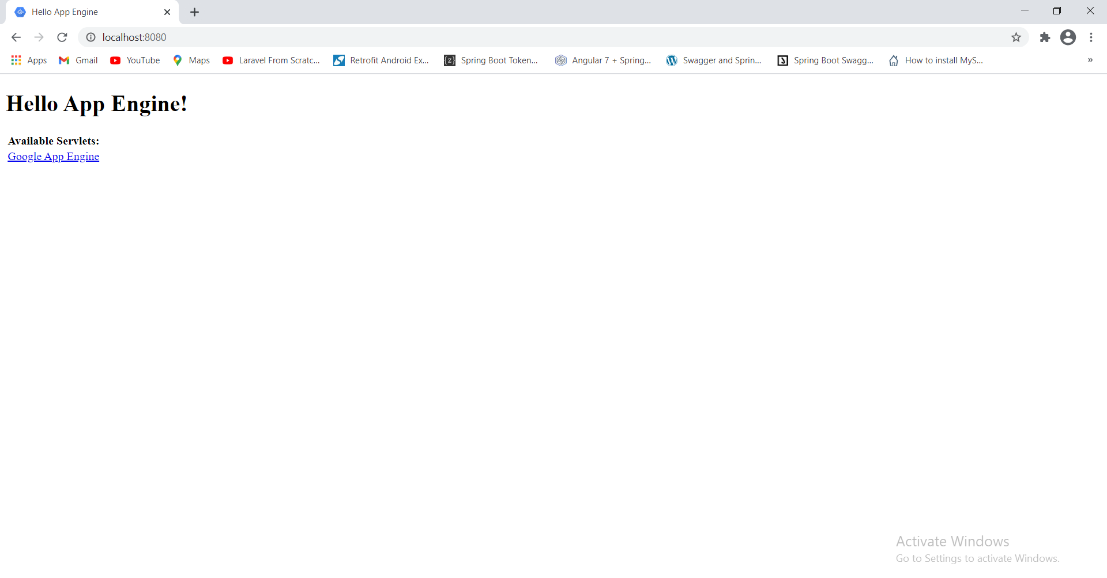

Click on this link “Google App Engine”. It will redirect with the address “localhost:8080/google app engine”.

